API Development for Forecasting Solar Power Generation Using Weather Data
Muhammad Miftah Faridh, Ida Bagus Krishna Yoga Utama, Ones Sanjerico Sitanggang, ByungDeok Chung*, Yeong Min Jang
Kookmin University, Seoul, Republic of Korea.
*ENS. Co. Ltd, Ansan, South Korea
muhammadmiftahfaridh@gmail.com, idabaguskrishnayogautama@gmail.com, onessanjerico@gmail.com, *bdchung@ens-km.co.kr, yjang@kookmin.ac.kr

Abstract— Fossil fuel usage for electricity and transportation is declining due to climate change and carbon footprints. Improved solar panel manufacturing has lowered the cost of generating solar energy, making it competitive with fossil fuels. Predictive models using time-series weather data can be developed to forecast solar power generation, aiding investment decisions and distribution system planning. This study introduces to employ various models, such as LSTM, Bi-LSTM, RNN, and Convolutional LSTM, to generate predictions using weather and solar power plant data. The output will be provided in the form of a Rest API, facilitated by the Flask framework.
Keywords—Deep Learning, Time Series, Forecasting, API

Introduction
Reliance on fossil fuels may cause a severe energy crisis. Pollution and greenhouse gas emissions associated with fossil fuels make them less reliable as future energy sources. This creates challenges in identifying and implementing cleaner and sustainable energy sources for future demands [1]. Solar and wind energy are weather-dependent sources that carry uncertainty. While solar power has a predictable pattern, posing a threat to power dispatch. Accurate forecasting tools can reduce deviations and help maintain reliability [2]. Solar PV panels' power production depends on solar irradiance, which follows a specific pattern but can vary depending on weather conditions and cloud cover [3].
Several models have been developed to predict solar irradiance and evaluate solar energy potential, including multi-regression and ANN models and new regression models that consider the clearness index and relative optical mass [4]. Artificial Neural Networks (ANN) are becoming increasingly popular for renewable energy forecasting due to their ability to overcome some time series model limitations. They are self-learning networks that can be trained with historical data to predict future values and can be organized in layers with inputs at the bottom and outputs at the top [5]. This research will use the Long short-term memory (LSTM), Bidirectional LSTM (Bi-LSTM), Recurrent Neural Network (RNN) , and Convolutional LSTM (ConvLSTM) models to produce forecasts based on solar power plant data and weather and produce output as a Rest Application Programming Interface (API) with the help of the Flask framework.

Methodology
Deep learning models will require various data to support learning, and this system will see multiple patterns during the specified iteration. The data used in this experiment is the weather data, where this data comes from the Korean Meteorology Administration (KMA), which provides open API. However, this data has shortcomings where we can use the actual data provided only for D-1, and they provide real-time data in the form of predictions. And for this research, the author uses accurate data to get real-time results by conducting learning together with solar power plant data from January 2021-October 2022.
After doing the forecasting process, this model will be used during the request process from the client in the form of ID from the PV factory, AI date and model, and the output will be a predictive value of PV power plants for the next day with data every hour from 00-23 more detailed explanations can be seen with Figure 1.

System Overview

Data Preprocessing
To prepare data for analysis, it is necessary to preprocess it to account for the sensitivity of power generation to variations. Missing data is interpolated using the nearest approach, and then the data is normalized using the MinMax method, which rescales data to a range of -1 to 1. Weather data features are eliminated based on the best correlation with power generation data, leaving only temperature, relative humidity, solar radiation, sunshine, and precipitation data. The input is then transformed into a sliding window format to create a sequence-to-sequence [6]. The data is divided into three corresponding sections: training data, validation data, and test data.

Deep Deep learning-model power generation forecasting using weather data
In this paper, various deep learning models such as LSTM, Bi-LSTM, RNN, and Convolutional LSTM. The experiment aims to determine the compatibility of several ANN models with the input data, weather data. To ensure that the training runs quickly, the batch size is set to 128, Adam is used as the optimizer with a learning rate of 0.01, iterations are set to 10,000, and a callback function is used to end the experiment if the data has converged or is close to overfitting

Evaluation Matrix
We have several discoveries related to the forecasted accuracy of time series data. The quality of the model is evaluated based on measures such as loss and validation loss. To assess the accuracy of the predictions, we utilized metrics like RMSE, mean absolute error (MAE), and mean square error (MSE). We calculated the error metrics using the following equation.
$MAE= \frac{\sum{|y_{i}-\hat{y}|}}{N}$ (1)
$MSE= \frac{\sum_{i=1}^{N}{{\left(y_{i}-\hat{y}\right)}^{2}}}{N}$ (2)
$RMSE= \sqrt{\frac{\sum_{i=1}^{N}{{\left(y_{i}-\hat{y}\right)}^{2}}}{N}}$ (3)
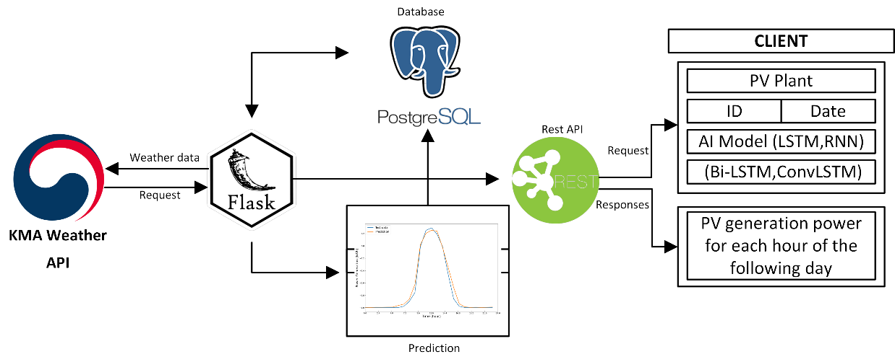
- Prediction graph on normalized power generation using BiLSTM

Rest API Testing
REST API testing involves verifying an API's functionality, reliability and performance through request and response verification. This study identifies endpoints and methods using Postman, understanding request and response formats, validating response codes and messages, and measuring response time and throughput.

Experimental Result
Table 1 displays the predictions of four deep learning models, revealing that BiLSTM achieves the most excellent performance across all evaluation matrices. The next best model is LSTM, followed by RNN and ConvLSTM. BiLSTM outperforms other deep learning models due to its architecture, which enables it to learn simultaneously from past and future data. Conversely, different models can only learn from past data. Figure 2 depicts the results of the predicted data generated with the actual data, indicating the excellent quality of the predictions based on the density between the lines.
- Model Performance
Model | MSE | RMSE | MAE
RNN | 0.023 | 0.1516 | 0.0979
LSTM | 0.0197 | 0.1404 | 0.088
ConvLSTM | 0.0265 | 0.1629 | 0.1117
BiLSTM | 0.0192 | 0.1387 | 0.0757

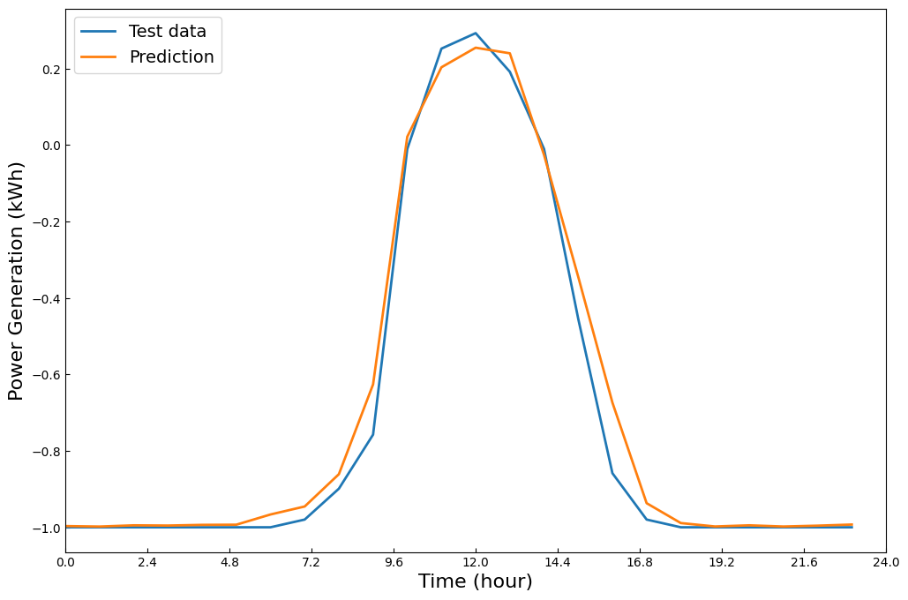
- Prediction graph on normalized power generation using BiLSTM
The testing of the Forecasting model was conducted on the Postman API Platform. The experiment involved sending requests to the server with specified parameters such as date format, site code or id, and AI model selection, which were previously tested. The server's response is in the form of predicted data for the next day's PV power plant based on the user's provided parameters.

Conclusion
In this study, a comparative model was developed to predict solar power generated by PV power generation using weather data. The Bi-LSTM model showed excellent performance across all evaluation metrics, as its learning process allows it to read both past and future data simultaneously. Additionally, a REST API was created using Flask and tested successfully with Postman. The researchers aim to explore online training AI models in the future further to improve the deep learning models' performance over time.

Acknowledgment
This work was supported by the Technology development Program (S3098815) funded by the Ministry of SMEs and Startups (MSS, Korea).

References
- V. Prema, M. S. Bhaskar, D. Almakhles, N. Gowtham, and K. U. Rao, “Critical review of data, models and performance metrics for wind and solar power forecast,” IEEE Access, vol. 10, pp. 667–688, 2022.
- S. Kumar, R. K. Saket, D. K. Dheer, P. Sanjeevikumar, J. B. Holm-Nielsen, and F. Blaabjerg, “Layout optimisation algorithms and reliability assessment of wind farm for microgrid integration: A comprehensive review,” IET Renew. Power Gener., vol. 15, no. 10, pp. 2063–2084, 2021.
- J. B. Holm-Nielsen, and F. Blaabjerg, “Layout optimisation algorithms and reliability assessment of wind farm for microgrid integration: A comprehensive review,” IET Renew. Power Gener., vol. 15, no. 10, pp. 2063-2084, Jul. 2021.
- M. G. De Giorgi, P. M. Congedo, and M. Malvoni, “Photovoltaic power forecasting using statistical methods: impact of weather data,” IET Sci. Meas. Technol., vol. 8, no. 3, pp. 90–97, 2014.
- J. R. Andrade and R. J. Bessa, “Improving renewable energy forecasting with a grid of numerical weather predictions,” IEEE Trans. Sustain. Energy, vol. 8, no. 4, pp. 1571–1580, 2017.
- I. B. Krishna Yoga Utama, D. H. Tran, and Y. M. Jang, “Short-term PM2.5 prediction using modified attention Seq2Seq BiLSTM,” in 2022 Thirteenth International Conference on Ubiquitous and Future Networks (ICUFN), 2022

